27/10/2027
4pm to 8 pm

This was my first time in kicad, did in easy eda part once After opening, I downloaded the XIAO ESP32C3 symbol and footprint But couldn't understand how to give me bel like, wait what!! what is meant by name and attach. Finally, I figured out that it means like write out and just attach it. But you rename after unzipping the schematic symbol and footprint. Anyways the rest of the connection I did easily since I used easy eda once helped me a lot.

Then after some time I realized that, I GOTTA MAKE A CHANGE. But just then my mind came that I can just attach a battery. YEAA. But which battery. I spend some time about researching which battery will be good and came up with 18650 single LIPO battery.
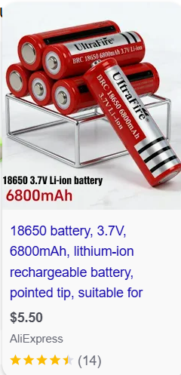
The reasn I choosed single because I saw double 18650 battery outputs nearly 7.5v which I may need to use again another buck converter to step down the volt, which I didn’t wanted to use. But single battery outputs nearly 4.5 v which I guess enough to powerup the esp32 and my clock. Then I added 01x02 connector,-. For the battery case. And here 01 means 1 row and 02 means 2 pins in one row
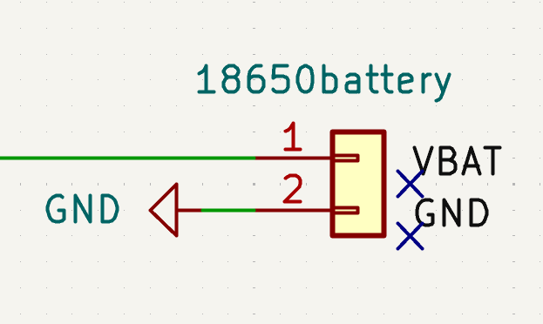
. And then now I have to add my footprints. AND HERE is the main problem I faced. I didn’t knew how to add footprint in kicad. Which in easyeda, its like maximum of footprints are already added with the symbols so I could directly move to PCB layout. But then I clicked somewhere and it showed my footprint .As you can see

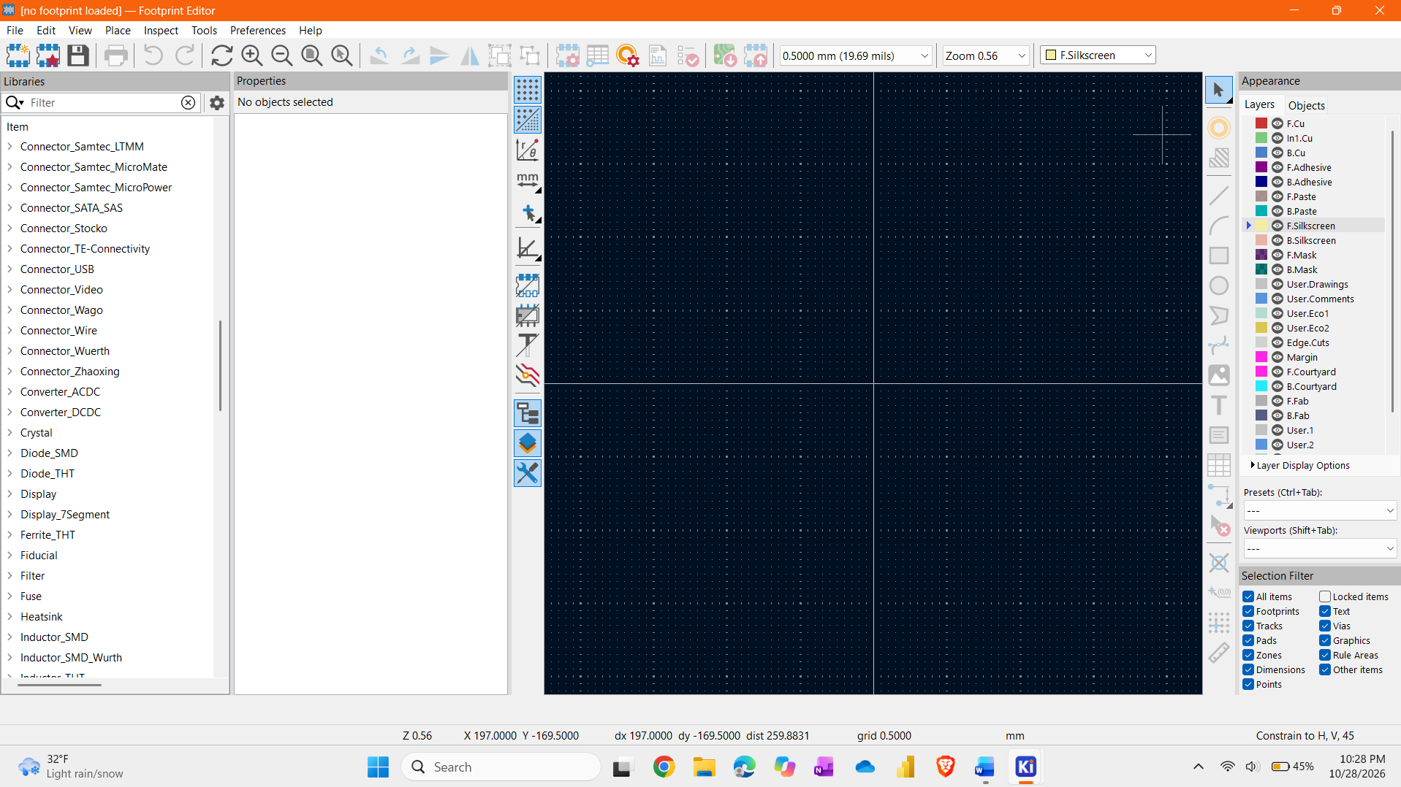
At first I was like, “Wait I can see the footprint BUT WHERE IS THE BUTTON FOR ADDING THIS FOOTPRINT TO SYMBOLL”

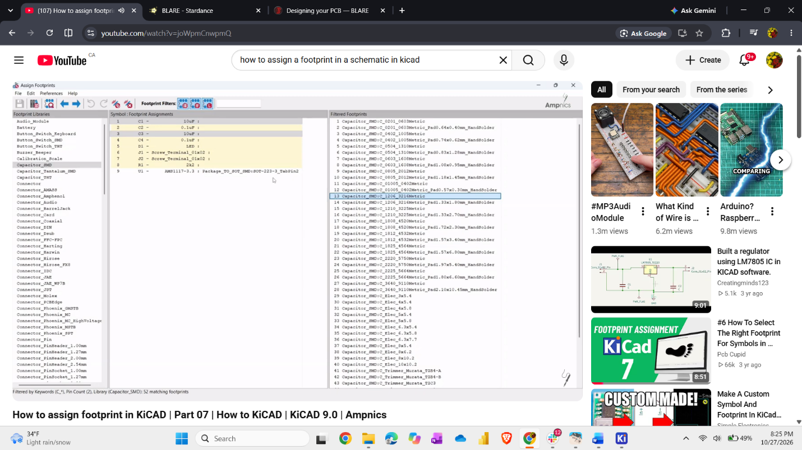
Then after some time, I went to youtube and searched for it Finally I understood how to add. Then I added my footprint and one thing I realized is that the kicad footprint is WAY MORE detail then EASYEDA.

……………………

30/10/2026
11:56 –

Its late night now. And Finally the weekend started and my homework almost finished. Now I sat to continue my work. SO I just realized like my PCB layout seems a bit big which you can see
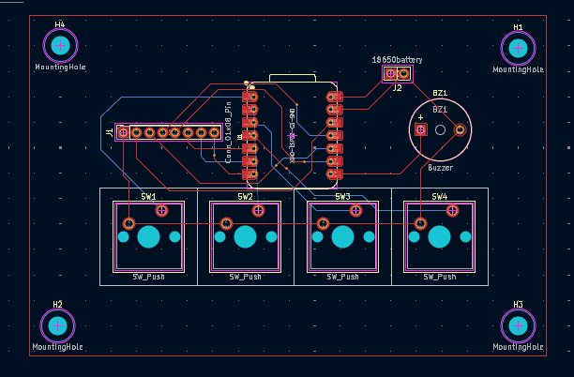

So I decided now to make it smaller. Because it will fit in the body easily then. But again I gotta wire some of the lines.

